 | BALMAS QUESTIONNAIRE | 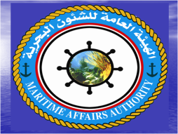  Maritime Affaires Authority  Republic of Yemen
1
 | To which existing ships in your fleet will the BWM Convention apply? | Ship name IMO number Vessel type GT Number of ballast tanks Total ballast tanks capacity
2
 | Have you already implemented any method of BWM? | NO
2.1
 | If you are using ballast water treatment (for D2 Standard), which technology do you use? | Non
2.2
 | Do your vessels have an approved BWM Plan? | NO
3
 | Do your vessels keep a BW Record Book? | NO
 | If YES, is it kept as a separate Record Book or as a part of another Record Book? | Non
 | Is it kept electronically? | NO
4
 | For vessels above 400GT in international navigation, have you instituted proceedings for issuing BW Certificate / Statement of compliance, in accordance with the BWM Convention? | NO
 | If YES, in which phase are the proceedings: | Non

