 | 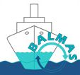  BALMAS QUESTIONNAIRE | 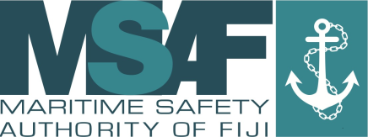  MARITIME SAFETY AUTHORITY OF FIJI
1
 | To which existing ships in your fleet will the BWM Convention apply? | Ship name IMO number Vessel type GT Number of ballast tanks Total ballast tanks capacity  Locally Registered vessel exempted.
2
 | Have you already implemented any method of BWM? | a) NO-  b) YES: MTD wef 1/1/15 Marine Ballast Water Regulation wef. 1/1/15  Port State Control Inspection. Use D2 standard
2.1
 | If you are using ballast water treatment (for D2 Standard), which technology do you use? | Mechanical filtration and separation, sterilization, chemical treatment or a combination of these treatment.
2.2
 | Do your vessels have an approved BWM Plan? | a) NO- Local Vessel exemption  b) YES- International vessels
3
 | Do your vessels keep a BW Record Book? | a) NO for local registered vessels  b) YES: International Vessels
 | If YES, is it kept as a separate Record Book or as a part of another Record Book? | a) separate RB  b) part of another RB
 | Is it kept electronically? | a) NO  b) YES
4
 | For vessels above 400GT in international navigation, have you instituted proceedings for issuing BW Certificate / Statement of compliance, in accordance with the BWM Convention? | a) YES wef. 1/1/15 for local legislation.  b) NO
 | If YES, in which phase are the proceedings: | a) Expected survey / PSC Inspection  b) Conducted survey  c) BW Certificate / Statement of compliance has been issued?  d) RO who has issued BW Certificate / Statement of compliance:  _________________________________________________

